DPS926 Project Description
Shudi Lin
125117150

Description
My project is a real-time Weather App that will show the temperature and other weather details such as wind speed and humidity. User is able to add his favourite cities to his list, and by clicking the list he can choose the city to display the weather detail.

UI/Work flow

Home page

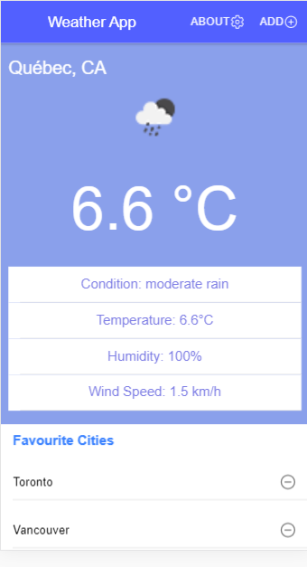

This is the home page, at the tool bar there are two buttons, About and Add. About leads to the about page showing details about this app, add leads to the add page, where user can add cities to the list. Under favourite cities, the user’s selected cities will be shown, and by clicking each of them, the top weather detail will change accordingly. User can also remove a city from his favourite list by clicking the minus button.

About page

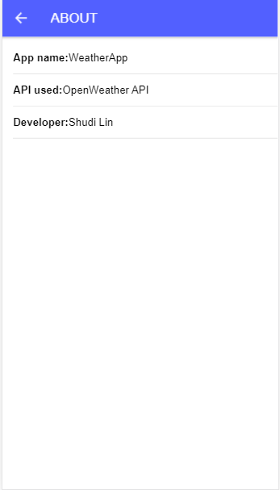

This is the about page showing details about this app, the API that was used to obtain weather information was OpenWeather API.

Add page
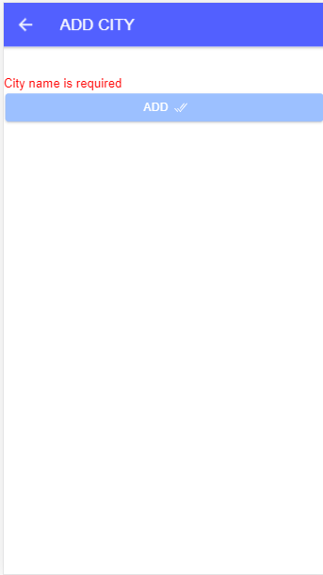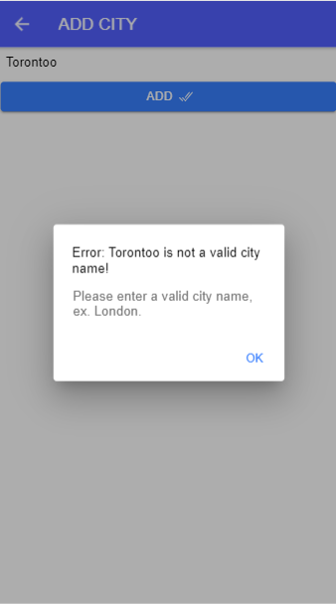

The add city page contains a simple form, and form validation. The user will need to enter a correct city name to add the city to his favourite list. If the API call fails, the city will failed to be added, and there will be an alert window telling user that the city name is incorrect.

